Wireframe for Custom Cricket Jerseys
Section 1:
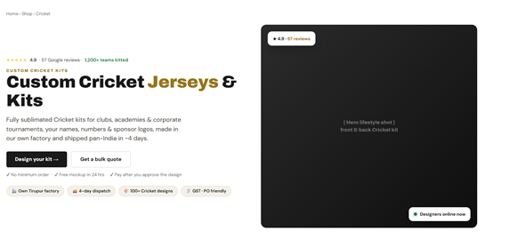
Section 2:
Section 3:
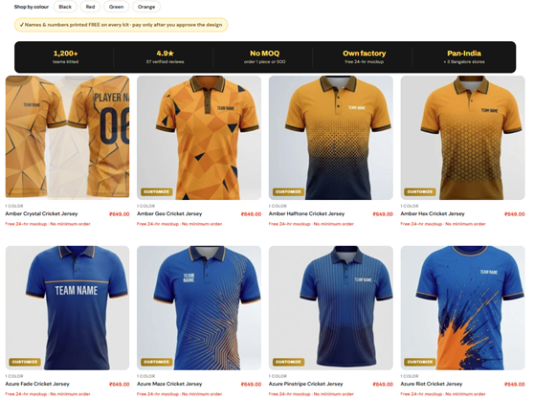

Section 4:
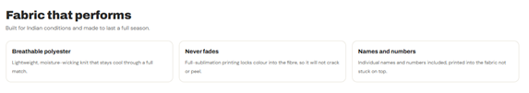
Section 5:
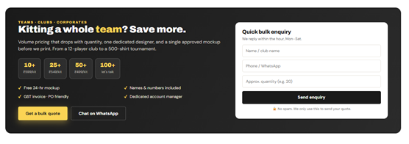
Section 6:
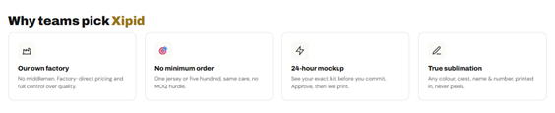
Section 7:
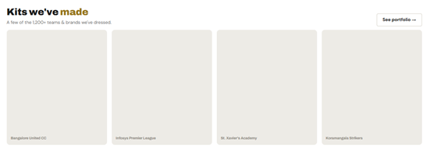

Section 8:
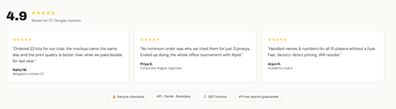
Section 9:


Section 10:
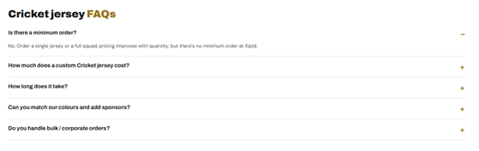
Section 11:

Section 12:
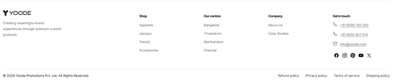
Wireframe for Blog Listing Page
Home > Blog
Section 1: Feature Blog

Section 2: Category Listing

Section 3: Listing all blogs

Section 4:

Section 5:

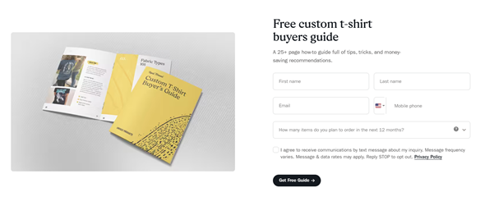
Section 6:



Section 7:
